Recommendation form for MSc applicants

Section A: to be completed by the applicant
Name: _____________________________ ID number: ____________________

Section B: to be completed by the referee
The above-named person has applied to the School of Molecular Cell Biology and Biotechnology at the Tel-Aviv University for M.Sc. studies. We should be grateful if you could provide a confidential reference on the applicant’s suitability.

1. How long have you known the applicant?
More than half a year _____ between 2 and 6 months ______ Less than 2 months ______

2. In what capacity have you known the applicant?
Lab project _____ Seminar _____ Regular course _____ Lab course _____
Other (specify) ___________________________________________________________

3. Please characterize the overall qualities of the applicant as best you can using the suggested numerical scale:
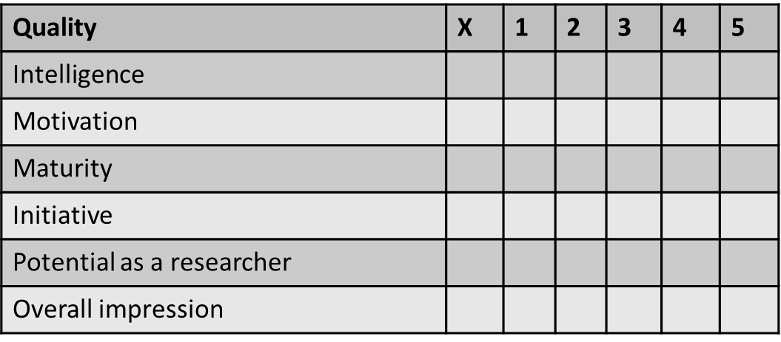
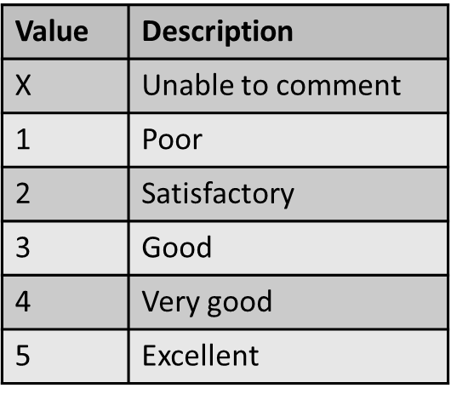

4. Would you accept the candidate as a M.Sc. student in your laboratory?
Yes ____, No _____ please indicate the reason(s): _______________________________________
_______________________________________________________________________________

5. General remarks about the candidate:

6. Referee’s details
Name (please print) ______________________________ Position _________________________
Institution and address ___________________________________________________
Telephone number ______________________
E-mail address _________________________

Signature _________________________ Date __________________

Please send to Head of MSc Committee - Prof. Gerardo Lederkremer (gerardo@post.tau.ac.il)

קריית האוניברסיטה, רמת -אביב, תל-אביב 69978, טל'03-6409413/03-6409080; פקס 03-6409407
RAMAT AVIV, TEL AVIV 69978, ISRAEL: TEL: 03-6409413/03-6409080 FAX: 972-3-6409407

